Carbon at Risk framework: enabling co-ordinated climate action at scale

**Acknowledgements: \***Bali Lee - Rethinking Removals, Paul Young - Kita, Ben Groom - Grantham Research Institute, LSE, Frederic Olbert - CarbonPool, Frank Venmans - Grantham Research Institute, Delia Meth-Cohn - Rethinking Removals, Gabrielle Walker - Rethinking Removals, *Nick Gogerty - Carbon Finance Labs

**Executive summary**

Carbon dioxide removal must scale nearly 7,000-fold in the next 25 years to meet climate targets, with each year of delay amplifying global warming. Balancing urgent action with long-term field development presents a critical challenge. Current carbon frameworks have helped established valuable quality standards. However, their reliance on binary classifications centred around “permanance” overlooks three crucial challenges:

* they ignore the urgency of avoiding tipping points,
* mask how different approaches could complement each other on our path to net-zero,
* and create arbitrary thresholds that stifle the innovation needed to reach net-negative.

Addressing these challenges requires understanding and managing two fundamental risks in carbon removal:

* Project delivery risk: When will the carbon actually be removed? Timing is crucial if we are to minimise tipping points risks.
* Physical storage risk: Once removed, how long will it stay stored? This determines our ability to maintain climate impact and ultimately achieve net-negative emissions.

The Carbon at Risk (CaR) framework simplifies assessment of these risks by combining them in a single metric: the maximum expected carbon dioxide losses over time, expressed as a percentage or kg/tonne at specified confidence levels. This enables meaningful comparison between different carbon removal approaches. For example, two projects might have vastly different risk profiles - one showing excellent short-term delivery but declining long-term durability, while another demonstrates higher initial delivery risk but greater long-term stability. Crucially, these risk assessments aren't static; they evolve as projects generate real-world data, allowing scores to be adjusted based on actual performance rather than initial projections.

Practically, these quantified risk profiles would enable insurers and registries to tailor coverage and buffer pool requirements to actual project performance. For example, the first project might require larger buffer pools to protect against long-term losses, while the second might need delivery guarantees but lower long-term reserves. This dynamic approach enables effective risk management and the rapid deployment of available but higher-risk solutions while more durable approaches mature. Better risk management leads to more accurate pricing, helping organisations strategically deploy diverse solutions as physical risks intensify for existing approaches while costs decline for emerging innovations.

The framework’s quantitative metrics also provide policymakers with market-tested tools for evaluating project performance, enabling evidence-based policies that can adapt to evolving risks driving continuous improvement in delivery and storage - creating the incentives needed for innovation toward climate restoration and net-negative emissions.

The power in this framework lies not in its technical design but in its potential to harness collective intelligence to solve our central challenge: balancing urgent climate action with long-term durability. By formalising and standardising risk management processes already used by insurers and project developers, CaR provides a common language for evaluating and managing the risks that determine the climate impact of a carbon removal project. As more stakeholders adopt CaR, their combined expertise and data would refine risk assessments, validate assumptions and surface new insights, bringing these mostly private risk assessments into the open, enabling more accurate pricing of carbon removal. With this foundation of transparent quantitative risk management, we can rapidly scale effective carbon removal approaches while driving continuous improvement.

**Table of contents**

1. The carbon removal gap: moving beyond binaries
2. Our proposed solution: the CaR framework
3. Calculating Carbon at Risk
4. How CaR enables coordinated action
5. Implementation considerations: building market infrastructure
6. Conclusion
7. References
8. Appendix

**The carbon removal gap: moving beyond binaries**

To meet our climate targets, carbon dioxide removals must grow from 1.35 million tonnes/yr today to 7-10 billion tonnes/yr by 2050 (Smith et al., 2024). That means growing carbon removals to nearly twice the size of global cement production (4.4 billion tonnes) in only three decades. Achieving such scale would be impossible if we were to use only a few of the approaches available to us, since each approach faces different fundamental constraints - from land and mineral resources to engineering expertise. It is therefore critical that we focus on innovating and scaling multiple billion tonne solutions rather than attempting to push a few past their practical limits. This broad approach has the added advantage of being much less risky.

However, with limited time and resources, we need more than just diversity - we need strategic investment and deployment based on measurable climate impacts. Yet current frameworks with their binary classification like “permanent” vs "non-permanent" or “nature” vs “technology”, lack the nuance to guide these crucial decisions, creating three critical problems:

1. **They ignore the crucial dimension of delivery timing.** Carbon dioxide has cumulative warming effects - the longer we wait to remove it, the greater the risk of crossing irreversible tipping points
2. **Binary classifications prevent effective comparison and collective action**. These frameworks sort solutions into rigid either/or categories, masking how different approaches could complement and strengthen each other on our way to net-zero.
3. **Fixed thresholds stifle innovation**. Solutions that fall just short of thresholds are undervalued, while those that meet them have no incentive to improve further - a necessity if we are to restore the climate and reach net-negative

**Our proposed solution: the CaR framework**

Carbon dioxide removal is a dynamic process, with risks that persist and evolve across time and space, whether the carbon dioxide is stored in the biosphere, geosphere or ocean. The Carbon at Risk (CaR) framework addresses these dynamics by measuring two distinct outcome risks:

* Project delivery risk: will the planned removal be delivered on schedule?
* Physical storage risk: once removed, will the carbon dioxide stay stored?

Formally, the CaR of any carbon dioxide removal project is defined as:

*Anticipated carbon dioxide losses (in kg/tonne or %) over a specified time horizon*[1] (e.g. 1, 10, 100, 1000 years)*, expressed with a chosen confidence level (e.g. 95%). For planned projects, this combines both project delivery risks and storage failure risks. Once drawdown is completed, it measures only storage risks.*

For example, consider a project with the following CaR scores

* 200kg/tonne over 10 years (20%), starting in 2025 (95% confidence)
* 215kg/tonne over 1000 year (21.5%), starting in 2025 (95% confidence)

This profile reveals that most of the project’s risk comes from delivery uncertainty in the first ten years, after which storage risk are relatively low, equating to only 15kg/tonne additional loss over the next 990 years. Thus, these multi-horizon CaR scores help stakeholders understand both total risk levels and when they're most likely to materialise.

Note: If by 2035 the project achieved 900kg/tonne of removal, it’s CaR scores would be updated to reflect the actual delivery and the remaining storage risk. The revised 1000 year score might therefore be 115kg/tonne over 1000 years (11.5%), starting in 2025.

This framework was developed over the past year in tandem with a group of stakeholders from across the carbon removal ecosystem. Key design choices made when developing this framework can be found in the Appendix (see Appendix A).

**Calculating Carbon at Risk**

CaR is an objective, statistical measure and practitioners using the CaR metric should leverage the best available tools, science and data. For established carbon removal approaches like afforestation, reforestation, and revegetation (ARR), practitioners can draw on historical data.

For newer approaches like ocean alkalinity enhancement (OAE), they may initially rely more on scientific modeling while acknowledging statistically the higher uncertainty in the CaR metric itself. Regardless of data source, transparency is crucial: users must clearly document their assumptions and data sources, apply methodology consistently across projects, and update their assessments as new real-world data becomes available.

The process of assigning a CaR score involves four key steps:

1. **Define project parameters**
   * Identify a specific pathway (e.g., biochar vs enhanced rock weathering)
   * Specify a methodology (e.g., solvent-based vs sorbent-based direct air capture)
   * Set an analysis time horizon

* Contract to drawdown period
* Drawdown to storage period
* Storage duration

1. **Identify material risk factors that could contribute to carbon dioxide losses:**
   * Extreme weather events
   * Containment breaches
   * Political changes
   * Scientific updates changing our understanding of extraction (or storage) effectiveness
2. **For each identified risk, estimate[2]:** 
   * Probability of occurrence
   * Severity (kg lost to the atmosphere per tonne)
   * Timing of potential losses
3. **Run simulations to determine aggregate risk:**
   * Establish the loss that is not exceeded in 95% (or 99%) of the simulations
   * Combine the impact of multiple risk factors including covariance of impacts

Over time, innovation from multiple parties with a shared language of risk should create an emergent "wisdom of crowds" effect, as multiple market participants assign and update CaR scores based on the latest data and modeling techniques. This collective effort of diverse views should lead to increasingly robust risk assessments as methodologies converge on standardised factors and approaches.

*When assessing natural carbon removal systems, CaR evaluates the durability of the entire system rather than its individual components. For example, while individual trees might live for 100 years, a forest ecosystem can persist for much longer through natural regeneration.*

*The key risk factors therefore emerge as institutional rather than biological - how effectively can legal frameworks and economic incentives prevent physical disruption of carbon storage? This systems-based approach allows CaR to assess thousand-year durability even for natural solutions, though achieving low CaR scores requires demonstrating how robust legal and economic frameworks will effectively prevent physical disruption of carbon storage over long time periods*

Examples of CaR curves and scores for different removal approaches can be seen in the appendix (appendix B). Furthermore, as with any framework there are limitations to what CaR can and can’t do. These have also been detailed in the appendix (appendix C).

## 

## **How CaR enables co-ordinated action**

Insurance companies and project developers routinely assess carbon removal risks - from project delivery through to long-term storage. CaR simply brings these practices into the open, creating a common language that all stakeholders can use to assess outcomes. This standardisation and transparency creates opportunities for action across three critical ares:

## 

First, CaR provides **risk management tools** that build on existing insurance practices to enable market-wide deployment of immediately available solutions, while developing new tools for building market confidence.

Second, it enables **strategic deployment** of carbon removal solutions, allowing organisation to effectively combine different approaches while balancing timing and storage security.

Third, it supports the development of **rules and regulations focused on outcomes** across voluntary and compliance markets, providing the systemic support needed for market growth while maintaining environmental integrity. This enables innovation in physical removal solutions, MRV approaches, and financial mechanisms - ultimately leading to more efficient and effective scaling.

**Risk management for immediate action**

Current frameworks ignore when carbon is removed, focusing solely on how long it stays stored. By evaluating risk across both project delivery and storage, CaR enables the safe deployment of available solutions today while more durable approaches mature - critical for addressing cumulative warming effects. This comprehensive risk assessment replaces rigid permanence thresholds with practical tools for managing real-world performance

By combining delivery and storage risk measurement, widespread adoption of CaR can drive development of crucial risk management infrastructure, building trust across the ecosystem:

* Premiums and/or buffer pool contributions based on measured performance would reward lower-risk project with cheaper insurance/lower-allocation requirements, driving continuous improvements in risk-management
* Clear comparison metrics and ratios for like-for-like credit replacements would enable buyers to maintain climate impact while diversifying supply risk
* Automatic payouts tied to verified shortfalls (e.g. less than 985kg/tonne of carbon stored, or more than 15kg/tonne lost over the defined period) would reduce administrative friction and increase transparency
* Standardised project assessments should streamline insurance underwriting making coverage more accesible to developers, investors and buyers.

This would create three immediate benefits

1. More stable and transparent pricing as the ecosystem can use CaR scores and associated risk management policies to properly price in risk
2. More sophisticated risk pooling across diverse removal approaches enabling both the diversification of project-specific risks and the management of systematic risks like El Niño events that can’t be diversified away
3. The development of new market mechanisms, such as using credits from low-risk project to offset riskier ones helping to drive demand for costlier more durable solutions

**Strategic deployment of carbon removal solutions**

Since no single solution will meet our removal goals. Oganisations need to combine diverse solutions for targetted outcomes. Current cost and supply barriers hinder the deployment of durable approaches. CaR provides clear metrics to compare performance outcomes. This balances the tension between, urgent action, long-term storage security and cost.

Consider two approaches to achieving 50,000 tonnes of durable carbon dioxide removal:

| **Portfolio type** | **Risk level** | **Amount (tonnes)** | **Current cost/tonne (£)** | **Future cost/tonne (£)** | **CaR// 1000 years** | **Current total cost (£)** | **Future total cost (£)** | **Durable Tonnes (95% likelihood)** | **Examples** |
| --- | --- | --- | --- | --- | --- | --- | --- | --- | --- |
| **Balanced Portfolio** |  |  |  |  |  |  |  |  |  |
|  | Low risk | 2,525 | 400 | 100 | 10kg | 1,010,000 | 252,500 | 2,500 | Direct air capture and BiomasCSS |
|  | Medium risk | 8,333 | 120 | 60 | 100kg | 999,960 | 4999,980 | 7,500 | High-quality biochar, enhanced rock weathering |
|  | High risk | 80,000 | 40 | 40 | 500kg | 3,200,000 | 3,200,000 | 40,000 | Restoration of natural carbon sinks#, reforestation, peatlands |
| **Total** |  | **90,858** |  |  |  | **£5,210,0**0 | **£3,952,48**0 | **50,000** |  |
| **Low-risk portfolio** |  |  |  |  |  |  |  |  |  |
|  | Low risk | 27,778 | 400 |  | 10kg | 11,111,200 | 2,777,800 | 27,500 | Direct air capture and BiomassCCS |
|  | Medium risk | 25,000 | 120 |  | 100kg | 3,000,000 | 1,500,000 | 22,500 | High-quality biochar, enhanced rock weathering |
| **Total** |  | **52,778** |  |  |  | **£14,111,200** | **£4,277,800** | **50,000** |  |

**Table X**: Comparison of balanced and low-risk portfolios achieving 50,000 tonnes of durable carbon dioxide removal. Higher-risk solutions require larger initial volumes to compensate for expected losses (effectively serving as their own buffer mechanism), while lower-risk solutions achieve the same outcome with smaller volumes at higher current costs. While the balanced portfolio appears significantly cheaper today (£5.2M vs £14.1M), projected cost reductions in lower-risk solutions narrow this gap considerably in the future (£4.0M vs £4.3M).

Measured by CaR both approaches, achieve the same storage of 50,000 tonnes over 1,000 years. However, this comparison reveals important dynamics:

* Higher-risk solutions can be effectively deployed by adjusting initial volumes to account for expected losses
* he balanced approach appears cheaper today (£5.2M vs £14M), projected cost reductions in lower-risk solutions will narrow this gap (£4M vs £4.2M)
* Investment across approaches provides both immediate impact and long-term reliability, while securing access to durable solutions (likely to be needed for future compliance)

This quantitative understanding lets organisations:

* Calculate and optimise their climate impact across time horizons
* Make informed trade-offs between urgency, durability and cost
* Plan technology transitions as risks increase, solutions mature and costs decline

**Creation of effective policy frameworks**

CaR can bridge voluntary and compliance markets by providing a common outcome metric to assess removal quality. Unlike fixed permanence thresholds, this quantitative approach incentivises ongoing improvements in project design,implementation and MRV across both delivery timing and storage duration. CaR equips policymakers with a tool that drives continuous improvement in removal quality, encouraging innovation and excellence across the carbon removal ecosystem.

**Strategic planning**

* Assess credibility of individual net-zero commitments through risk-adjusted evaluation of planned removals
* Guide public investment by targeting solutions with low CaR scores while also supporting those showing potential for significant risk reduction
* Enable accurate tracking of collective progress toward global targets (e.g., 5Gt by 2050) through standardised measurement of national contribution outcomes

**Market design and regulation**

* Set dynamic evidence-based criteria for compliance markets that reward better performance
* Create incentive structures rewarding both near-term delivery and long-term storage
* Match emissions with equivalent-risk removal assets in "polluter pays" system - aligning storage duration with atmospheric lifetime (e.g., 12-year methane vs. century-scale CO2)
* Design scalable buffer pool systems that adjust requirements based on demonstrated performance

**Implementation mechanisms**

* Structure procurement programs based on risk-adjusted outcomes across both delivery and storage
* Create tax incentives that scale with storage security (e.g., higher incentives for solutions demonstrating <100kg/tonne loss over 100 years)
* Require standardised CaR disclosure across both time horizons and delivery schedules, enabling buyers to differentiate between solutions that might all be labeled 'permanent' but vary significantly in their storage security (e.g., at 1000 vs 10000 years) and when they actually remove carbon

Note: See appendix (appendix D) for detailed exploration of how different stakeholders - from project developers to financial institutions - can participate in and benefit from CaR implementation

**Implementation considerations: building market infrastructure**

CaR can provide immediate value for individual organisations making carbon removal decisions. However, developing supportive market infrastructure will help maximise its impact across the ecosystem. Three areas in particular can enhance CaR’s effectiveness:

**Data sharing and transparency**

CaR's strength lies in its ability to work with available data while naturally improving over time. Organizations can begin using CaR immediately - uncertainty in data simply translates to wider confidence intervals and higher declared loss factors. As more data becomes available and our understanding improves, these uncertainties naturally narrow, improving the accuracy of risk assessments.

This elegant design creates a virtuous cycle: early adopters can start with conservative estimates based on limited data, while their experience generates new data that helps refine future assessments. Over time, as more organisations share performance data and outcomes, the collective knowledge base grows, enabling increasingly precise risk quantification across different removal approaches.

The framework particularly benefits from:

For risk management:

* Standardised templates that make it easier to compare and aggregate project data
* Growing datasets that help validate and refine risk models
* Secure platforms for sharing performance data while protecting sensitive information

For strategic deployment:

* Comparative analysis of how different approaches perform in practice
* Better understanding of how risks evolve as technologies mature

For policy development:

* Evidence-based insights into actual project performance
* Shared learning across different regulatory frameworks

The private sector, particularly insurance markets, can accelerate this improvement cycle. Just as automobile insurers helped advance vehicle safety through data-driven research, carbon removal insurers can drive better understanding of project risks and mitigation strategies. But crucially, we don't need to wait for perfect data - CaR's design allows us to start today while systematically improving accuracy over time.

**Testing and refinement**

The CaR framework is a new concept the requires testing and continual refinement through to its real-world application. Carbon removal buyers, suppliers, and intermediaries can support this process by piloting CaR-based research, declarations, reporting, transactions and then sharing lessons learned. The key is to start small, learn by doing, and iterate based on ongoing research and feedback from current and new market participants.

For risk management:

* Report past projects based on CaR using historical performance data
* Pilot insurance products based on CaR scores
* Initiate third party ratings firms to report CaR estimates for projects
* Trial buffer pool designs that combine different risk profiles
* Test using CaR for deciding like-for-like credit replacement should a project fail as risk remediation

For strategic deployment

* Pilot real-world portfolio optimisation across different removal approaches and CaR scores
* Refine transition planning as costs and CaR scores evolve

For policy development

* Trial regulatory frameworks referencing CaR thresholds for delivery of projects or portfolios
* Test monitoring and verification systems
* Pilot international adjustment mechanisms

CaR's strength lies not in generating perfect initial scores, but in creating a common language that enables meaningful dialogue about risk across the carbon removal ecosystem. When project developers, verifiers, insurers, and other stakeholders can discuss specific risk factors and their likelihood using shared terms and metrics, they can better understand and manage those risks - even if they initially disagree on the exact numbers. This structured way of comparing perspectives and sharing insights will naturally lead to more refined risk assessments over time, replacing binary debates about "permanence" with nuanced conversations about actual project performance and risk management.

**Governance and standards**

As CaR adoption grows through market-led initiatives, it is likely that governance frameworks will naturally emerge to support scaling and standardisation. This governance structure could include trusted “CaR rating agencies” and/or methodological implementations in regards to treatment of contributin risk factors that validate assessment methodologies across insurance companies and registries, develop frameworks for updating risk assessments as technologies mature, and handle disputes for when shortfalls occur.

Over time, the market should converge on common metrics and reporting formats (e.g., standardised time horizons like 200 years and confidence levels like 95%), although these may vary among stakeholder groups depending on needs. This kind of standardisation enables meaningful comparison across different approaches and solution sets.

Furthermore, while organisation may use varying methodologies to calculate specific risks, standardised approaches for combining timing and storage outcomes should emerge, including whether or not to discount for time. This consolidation will provide reliable risk benchmarks (wisdom of crowds), while preserving methodological diversity to protect against systemic failure that could arise from uniform risk assessment approaches (everyone making the same mistake).

The development of these conventions will likely contribute to market-led adoption within and beyond formal policy frameworks. While many risk assessment practices can emerge organically through market adoption, governments will need to establish stringent verification protocols and evidence-based criteria for market participants and clarity. These regulatory frameworks can build on market-tested approaches - for example, adopting insurance industry risk assessment methods to develop standardised buffer pool requirements that reflect actual performance v. overly proscriptive static values.

**Conclusion**

Meeting our climate goals demands unprecedented innovation in how we deploy and scale carbon removal solutions. While technical advancement is crucial, equally important is how we evaluate and implement these solutions. Given the urgency of the climate challenge, we cannot wait for perfect technologies before taking action.

Fortunately, we have a range of carbon removal approaches available today. However, current evaluation frameworks, with a crude focus on storage duration, risk overlooking solutions that could provide immediate impact despite having shorter storage times. The CaR framework addresses this limitation by measuring both project delivery and storage failure risks - revealing the substantial reliance on carbon removal approaches that have yet to be deployed.

By bringing both project delivery and storage risks to the forefront, CaR enables better strategic planning and encourages immediate action through effective risk management. For insurance and buffer pools in particular, CaR provides powerful tools for optimising risk coverage by enabling risk pooling across diverse carbon removal approaches.

For example, registries can achieve higher storage security in their buffer pools by combining high-risk and low-risk carbon removal approaches. Additionally, by enabling clear quantification of project risks, CaR could help stabalise prices as buyers and sellers can more effectively price and transfer in both delivery and storage risks.

The framework also reveals important insights about carbon removal deployment. Immediately available, but higher risk solutions can be deployed effectively by increasing initial volumes to account for storage risks e.g. investing in 100,000 tonnes of reforestation removals but claiming only 50,000.

Furthermore, while strategies balancing this approach with other less-risky approaches may be significantly cheaper today. Projected cost reductions in lower-risk solutions will substantially narrow this gap. This suggests that investing across approaches provides both immediate climate impact and long-term reliability, while securing access to durable solutions required for future compliance.

For policymakers, CaR provides tools to design frameworks that encourage continuous improvement. Rather than setting fixed permanence thresholds for proscribed pathways, policies can use risk-adjusted metrics to reward projects that deliver reliable carbon removal quickly.

This quantitative outcomes focused approach helps inform public investment in removal infrastructure, enabling the rapid adoption of evidence-based criteria for compliance markets and provides a foundation for international cooperation on removal targets.

CaR is not a complete climate solution - it deliberately focuses only on physical carbon outcomes while leaving aside important factors like scaling potential and co-benefits. However, it makes meaningful progress in balancing urgent climate action with long-term durability. The framework’s power lies not in its technical design but in its potential to harness collective intelligence and learning over time, regulatory and technical domains.

As more stakeholders adopt CaR, their combined expertise will refine risk assessment, validate assumptions, and surface new insights, creating a virtuous cycle of continuous improvement in how we evaluate and manage carbon removal risks.

Ultimately, achieving gigatonne-scale carbon removal requires unprecedented collaboration across the entire ecosystem. By providing a common language for understanding and managing project delivery and storage risks, CaR enables stakeholders to move past binary thinking and take confident action today while building toward more durable solutions. The challenge ahead is immense and time is short, but by working together to better understand and manage risk, we can build the robust carbon removal ecosystem we need to meet our critical climate goals.

****

**REFERENCES**

Bauer, Michael D. and Glenn D. Rudebusch (2023) The Rising Cost of Climate Change: Evidence from the Bond Market. The Review of Economics and Statistics; 105 (5): 1255–1270. doi: <https://doi.org/10.1162/rest_a_01109>

Brander, Matthew and Derik Broekhoff (2023), Methods that equate temporary carbon storage with permanent CO2 emission reductions lead to false claims on temperature alignment,” Carbon Management, 2023, 14 (1), 2284714

Drupp M, Freeman M C, Groom B and Nesje F (2018). ‘Discounting Disentangled: An Expert Survey on the Components of the Long-Term Social Discount Rate’. American Economic Journal: Economic Policy, 10 (4), pp 109-34.

Gogerty, Nick and Johnson, Paul, *Carbon at Risk: A Value-at-Risk Approach to Carbon Management* (February 22, 2024). Available at SSRN: <https://ssrn.com/abstract=4745542>

Groom B and Venmans F (2023). ‘[The Social Value of Offsets](https://doi.org/10.1038/s41586-023-06153-x)’. Nature, 619, pp 768-773.

Howard P, et al. (2023). ‘US Benefit-Cost Analysis requires revision.’ Science, 380 (6647), pp 803.

O’Hare, Michael et al. (2009) “Proper accounting for time increases crop-based biofuels’ greenhouse gas deficit versus petroleum,” Environmental Research Letters, 4.

# **Appendix:**

**A**

**Design choices made in the Carbon at Risk Framework**

The CaR framework was carefully designed to strike a balance between accuracy and practicality, ensuring it meets the needs of various stakeholders involved in carbon removal projects. Each key factor in CaR was chosen to make the framework reliable and user-friendly, allowing for implementation in multiple ways by different parties.

**Trade-offs between accuracy & utility**

**1. Focus on physical risks**

**Trade-off:** While carbon removal projects face many types of risks (regulatory, political, financial), including all of these would make the framework unwieldy and imprecise.

**CaR's approach:** The framework focuses exclusively on quantifying physical risks to carbon removal and storage. This deliberate scope limitation enables precise measurement in a single, understandable metric (kg/tonne), making it both rigorous and practical to use.

**2. Project delivery and storage risks**

**Trade-off:** Traditional frameworks focus mainly on storage risks ('permanence'), treating carbon removal as a single process. This overlooks crucial project delivery risks, especially important for new technologies and long-term offtake agreements.

**CaR's approach:** The framework explicitly separates extraction risk (failure to get carbon dioxide out of the atmosphere) from storage risk (failure to keep it out). This distinction enables more precise risk assessment and better reflects the reality of different carbon dioxide removal approaches, where extraction and storage may be distinct processes with different risk profiles.

**3. Multiple time horizons:**

**Trade-off:** While choosing a single standardised time horizon would make the framework simpler, it would limit its utility since different stakeholders need to understand risk over different timeframes.

**CaR's approach:** Rather than imposing a single timeframe, CaR enables risk assessment across multiple time horizons (e.g., 1, 10, 100, 1000 years). This flexibility is a key feature of the framework, allowing stakeholders to choose between more precise near-term assessments or broader longer-term projections based on their specific needs. For example, an insurer might focus on detailed near-term risk assessment, while a regulator might need to consider longer-term storage outcomes.

**4. Flexible confidence levels**

**Trade-off:** While choosing a single standardised confidence level (like 95%) would make the framework simpler to communicate, different use cases require different levels of certainty in risk assessment.

**CaR's approach:** Rather than prescribing a fixed confidence level, CaR allows users to select the threshold appropriate for their needs. While examples in this text use 95% confidence for illustration, stakeholders can adjust this based on their risk tolerance and requirements. For example, a project developer might use lower confidence levels for initial feasibility assessments, while an insurer setting premiums might require higher confidence in their risk calculations

**5. Standardisation vs. customisation**

**Trade-off:** While requiring everyone to use the exact same methodology would ensure perfect comparability, it would limit innovation and prevent adaptation to specific project needs.

**CaR's approach:** CaR standardises how risk is expressed (kg/tonne) while allowing flexibility in how these risks are calculated. This enables like-for-like comparison of results while encouraging methodological innovation and adaptation to different project types.

**6. Balancing data precision with practicality**

**Trade-off:** Perfect risk quantification would require impossibly detailed data and complex modeling, but carbon markets need a practical solution that can be implemented today.

**CaR's approach:** The framework uses the best available data and models, emphasizing transparency in assumptions. While it may not capture every minor risk, it provides a practical level of accuracy that is sufficient for informed decision-making.

**7. Treatment of co-benefits**

**Trade-off:** While social and environmental co-benefits are crucial aspects of carbon removal projects, including them in risk assessment would blur the clarity of physical carbon outcomes.

**CaR's approach:** The framework deliberately separates physical carbon risk assessment from co-benefit evaluation. This enables precise quantification of carbon outcomes while allowing co-benefits to be properly assessed through specialised frameworks (like UN Sustainable Sevelopment Goals) and valued independently within buyers' ESG strategies. 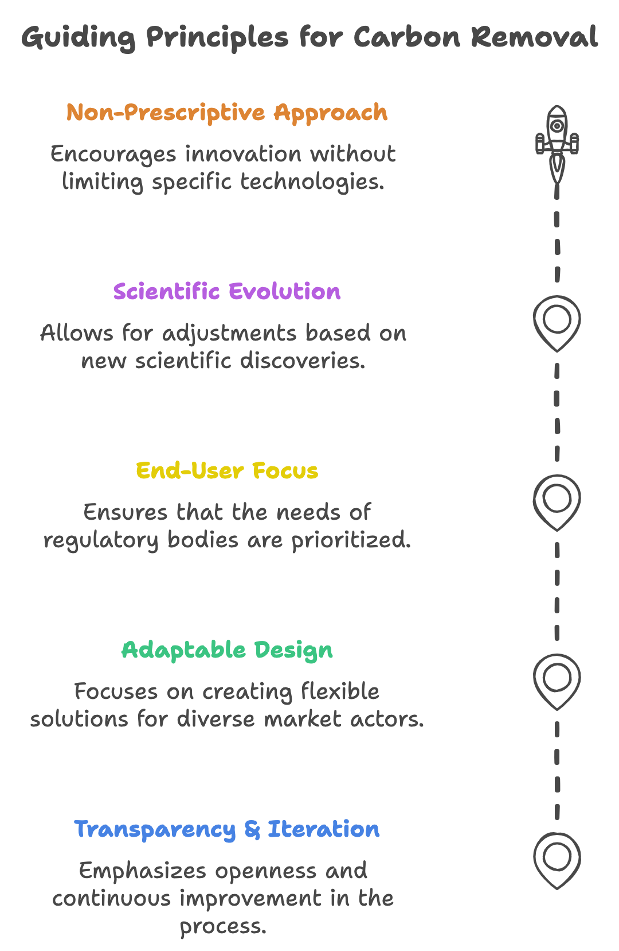

**8. Timing of removal events**

**Trade-off:** A simpler approach would be to assess all carbon removals based solely on their total quantity, ignoring when they occur. However, this would miss crucial differences between near-term and future removals, and overlook the increased uncertainty in future removal predictions.

**CaR's approach:** By separating extraction from storage risks, the framework enables precise assessment of when carbon dioxide will be removed from the atmosphere. This temporal precision allows stakeholders to appropriately value and compare projects based on their removal timing, creating incentives for early action when it matters most given the risk of climate tipping points.

**The overarching goal was to maximise utility of a common language of risk across stakeholder domains.**

**B**

**Illustrative examples**

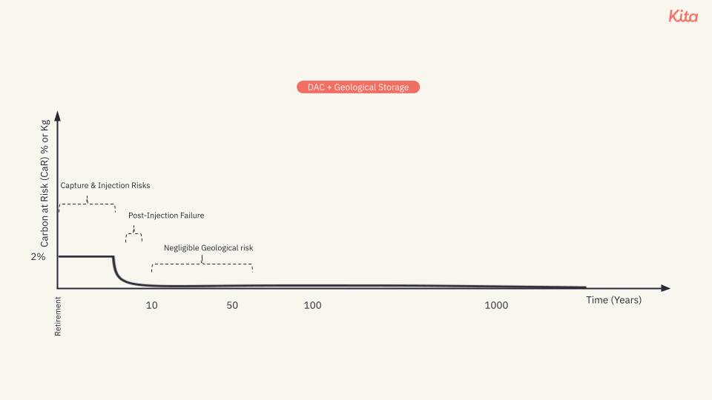

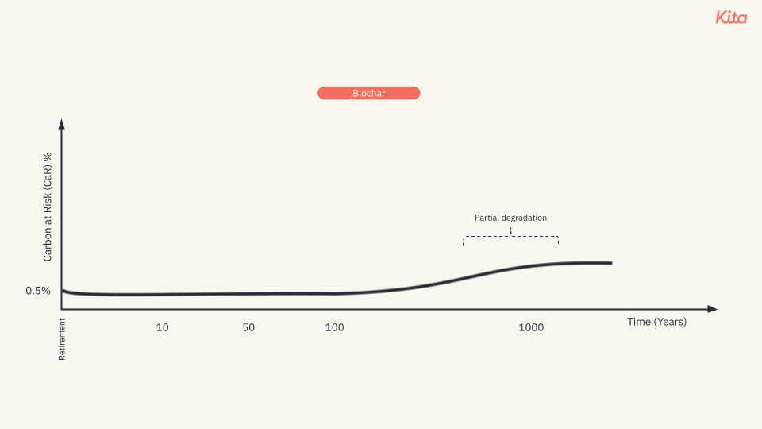

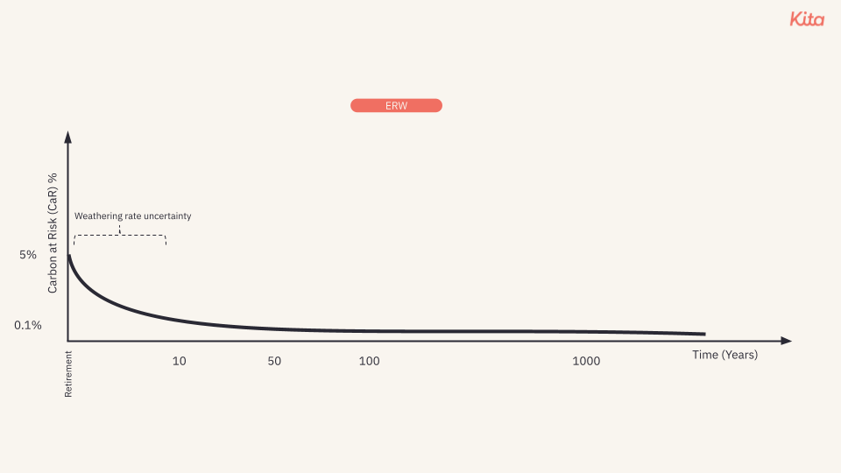

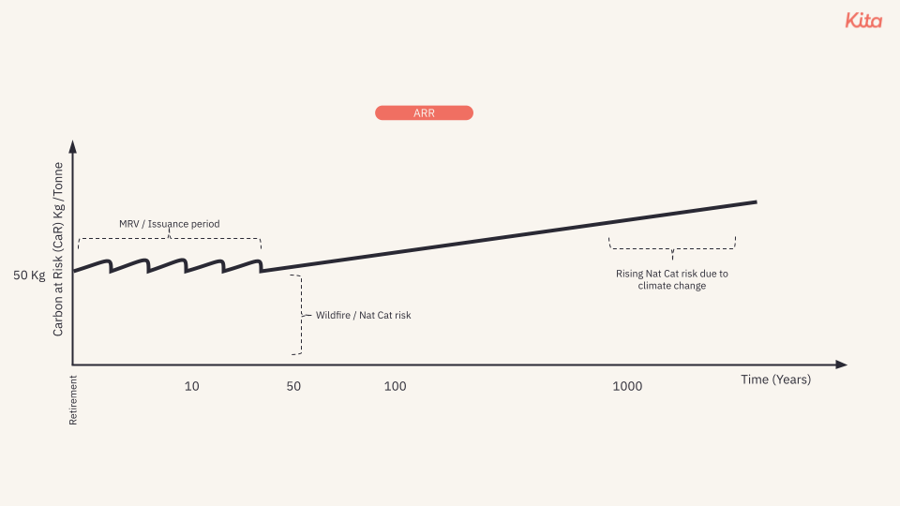

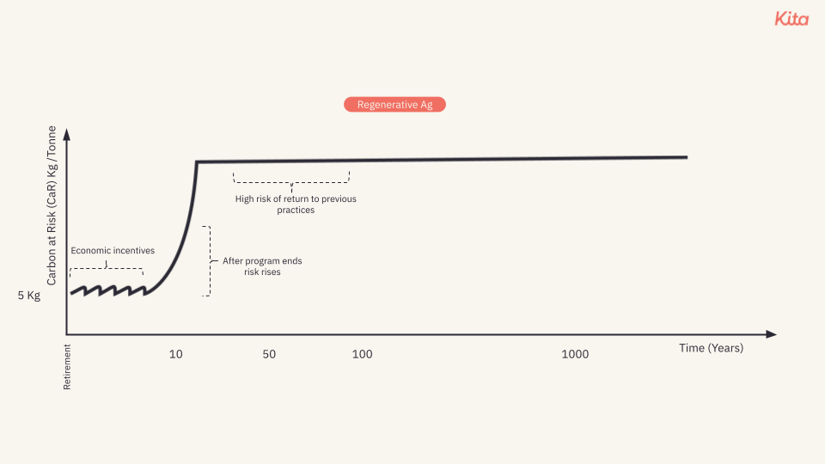

**C**

**Limitations and Scope of the CaR Framework**

To enable appropriate application of CaR, it is important to clearly define its scope and limitations. The framework is designed specifically to quantify physical risks to carbon dioxide removal and storage. Understanding these boundaries helps ensure effective use of the framework and appropriate integration with complementary tools and approaches.

Key limitations include:

**Physical risks only:** CaR focuses exclusively on physical risks to carbon dioxide extraction and storage. It does not assess:

* Additionality
* Financial viability
* Social and environmental co-benefits
* Regulatory compliance
* Project governance

**Measurement not certification**: CaR provides a standardised risk metric but does not:

* Replace project certification requirements
* Eliminate need for due diligence
* Serve as a comprehensive project assessment tool

**Data dependent**: The framework's effectiveness relies on:

* Quality and availability of input data
* Transparency of assumptions
* Standardised reporting formats
* For novel technologies or early-stage projects, limited historical data may increase uncertainty in assessments.

CaR should be viewed as one component within a broader risk management strategy, complementing other assessment methodologies and tools. Clear communication about its scope and proper interpretation of CaR scores is essential for effective use.

**D**

**Practical implementation across stakeholders**

Different stakeholders can use CaR in ways that suit their specific needs while contributing to overall market growth:

**Project developers**

* Demonstrate project quality through quantified risk assessment
* Access insurance and financing based on clear risk metrics
* Optimise project design to minimize CaR scores
* Support price premiums for lower-risk approaches

**Buyers**

* Build balanced portfolios across risk profiles
* Match removal approaches to specific use cases
* Manage long-term climate commitments
* Support early-stage solutions while managing risks

**Financial institutions**

* Develop innovative financing mechanisms
* Price risk accurately in carbon removal investments
* Create new insurance products
* Structure long-term offtake agreements

**Standards Bodies**

* Set evidence-based quality criteria
* Design appropriate buffer pool requirements
* Develop monitoring and verification protocols
* Enable comparison across different standards

# **E**

# **Benefits actors receive from Carbon at Risk (CaR) framework.**

This table simplifies how CaR facilitates benefits within the carbon removal ecosystem, aiding in scaling the market to gigatonnes of removals by 2050.

Benefits of the Carbon at Risk (CaR) framework to stakeholders

| **Stakeholder** | **Benefits from CaR** | **Interactions with Others** |
| --- | --- | --- |
| **Project Developers** | - **Access to Investment**: Quantified risks make projects more attractive to investors.  - **Improved Project Design**: Risk insights from CaR help enhance project robustness.  - **Simplified Certification**: Clear risk metrics streamline the certification process. | - **With Investors**: Provide CaR data to secure funding.  - **With Verifiers/Certifiers**: Use CaR for easier verification.  - **With Scientists/Researchers**: Collaborate to improve risk models. |
| **Buyers** | - **Informed Purchasing Decisions**: Standardized risk metrics aid in selecting projects.  - **Confidence in Outcomes**: Trust in long-term carbon removal effectiveness.  - **Simplified Due Diligence**: Reduced need for extensive individual assessments. | - **With Project Developers**: Obtain CaR data for decision-making.  - **With Insurers**: Secure insurance based on quantified risks.  - **With Carbon Markets/Exchanges**: Trade credits with confidence using CaR metrics. |
| **Investors** | - **Quantified Risk Assessment**: Better analysis for investment decisions.  - **Confidence in Viability**: Increased trust in project success and returns.  - **Portfolio Optimization**: Diversify investments based on CaR scores. | - **With Project Developers**: Evaluate projects using CaR data.  - **With Insurers**: Mitigate investment risks.  - **With Policy Makers**: Align investments with regulatory standards informed by CaR. |
| **Insurers** | - **Accurate Risk Pricing**: Use CaR data to develop tailored insurance products.  - **Market Expansion**: New opportunities in carbon removal insurance.  - **Reduced Uncertainty**: Better underwriting through standardized risk metrics. | - **With Project Developers**: Provide insurance based on CaR assessments.  - **With Buyers and Investors**: Offer products to cover potential losses.  - **With Scientists/Researchers**: Improve risk models for better products. |
| **Policy Makers / Regulators** | - **Standardized Policy Frameworks**: Use CaR to set clear regulations.  - **Enhanced Monitoring**: Better enforcement of environmental goals.  - **Market Alignment**: Ensure market activities meet climate objectives. | - **With All Stakeholders**: Use CaR data to inform policies.  - **With NGOs**: Receive feedback on policy effectiveness.  - **With Carbon Markets/Exchanges**: Regulate based on standardized metrics. |
| **Carbon Markets / Exchanges** | - **Increased Transparency**: CaR provides clear information for all participants.  - **Standardized Trading Units**: Simplifies transactions and pricing.  - **Enhanced Trust**: Builds confidence among buyers and sellers. | - **With Buyers and Sellers**: Facilitate trades using CaR metrics.  - **With Regulators**: Ensure compliance with policies informed by CaR.  - **With Verifiers/Certifiers**: Confirm the integrity of traded credits. |
| **Verifiers / Certifiers** | - **Streamlined Processes**: Clear criteria based on CaR simplify verification.  - Enhanced Credibility: Standardized assessments increase trust in certifications.  - **Efficiency Gains**: Reduced time and resources needed for verification. | - **With Project Developers**: Verify data using CaR framework.  - **With Policy Makers**: Align certification standards with regulations.  - With Carbon Markets: Provide verified credits for trading. |
| **Scientists / Researchers** | - **Application of Research**: Direct impact on real-world projects through CaR.  - **Data Access**: Utilize project data to refine models.  - **Contribution to Improvement**: Enhance the CaR framework with latest findings. | - **With Project Developers**: Collaborate on improving risk assessments.  - **With Insurers**: Provide insights for better risk pricing.  - **With Policy Makers**: Inform regulations with scientific evidence. |
| **NGOs / Environmental Groups** | - **Transparency and Accountability**: Access to CaR data for monitoring.  - **Effective Advocacy**: Use standardized metrics to influence policy.  - **Public Trust**: Enhanced credibility through evidence-based assessments. | - **With Policy Makers**: Advocate for policies based on CaR data.  - **With the Public**: Educate on environmental impacts using CaR insights.  - **With Project Developers**: Monitor compliance and environmental integrity. |

## **F**

## **Stakeholders and their relationships to Carbon-at-Risk:**

| **Stakeholder Category** | **Current Challenges** | **Benefits of CaR Framework** | **Potential Quantifiable Impact** |
| --- | --- | --- | --- |
| **Market Actors** | | | |
| **Project Developers** | Fixed buffer pools reduce project viability  Uncertain risk pricing | Risk-adjusted pricing  Lower capital requirements  Better project planning | 15-30% increase in project ROI  20-40% reduction in required buffers |
| **Credit Traders** | Limited risk hedging tools  Binary risk assessment | Dynamic risk pricing  New derivative products  Better portfolio management | 2-5x increase in market liquidity  25-50% reduction in trading spreads |
| **Credit Purchasers** | Uncertain credit quality  Limited risk transparency | Clear risk metrics  Better purchase decisions  Risk-adjusted pricing | 10-20% reduction in credit costs  Better alignment with internal risk policies |
| **Risk Managers** | | | |
| **Insurers** | Limited actuarial data  Unclear risk models | Statistical risk framework  Better product design  Clear pricing models | New $1-5B market opportunity  30-50% better risk assessment |
| **Actuaries** | Lack of historical data  Limited modeling tools | Standardized risk metrics  Better data analysis  Clear methodology | 40-60% improvement in risk modeling accuracy |
| **Risk Innovators** | Few established products  Limited market acceptance | New product development  Clear risk frameworks  Market expansion | $2-10B new financial products market |
| **Oversight Bodies** | | | |
| **Financial Regulators** | Limited oversight tools  Unclear risk standards | Standard risk metrics  Better market oversight  Clear compliance framework | 50-70% reduction in regulatory uncertainty |
| **Verification Bodies** | Binary verification approach  Limited risk assessment | Risk-based verification  Better assessment tools  Clear standards | 30-50% efficiency improvement in verification |
| **UNFCCC** | Limited market oversight  Unclear risk standards | Global risk framework  Better market function  Clear standards | 2-3x increase in market confidence |

1. In other words, the CaR is the 95th percentile of the probability distribution of carbon losses. Note that CaR for individual small projects on a yearly time horizon can be less informative, because the likelihood of keeping all carbon will generally exceed 95%, leading to a CaR of 0% even for relatively risky projects. The CaR of a single small project for a 1000 year time horizons may be similarly uninformative, because the likelihood of losing all carbon will often exceed 5%, leading to a similarly uninformative CaR of 100%, even for a safe project.
2. These estimates can be based upon historical data (where available), scientific models and projections, expert judgment with clear documentation of assumptions etc.